Docker Assignment-2

Create 2 branches 2026Q1 and 2026Q2 in github which are having index.html files. Jenkins master and 2 slave machines. whenever there are changes in index file on slave machines new container needs to be created and that index file needs to be deployed on that so that we can access the index file on browser.
1. Launch Jenkins master and 2 slave machines
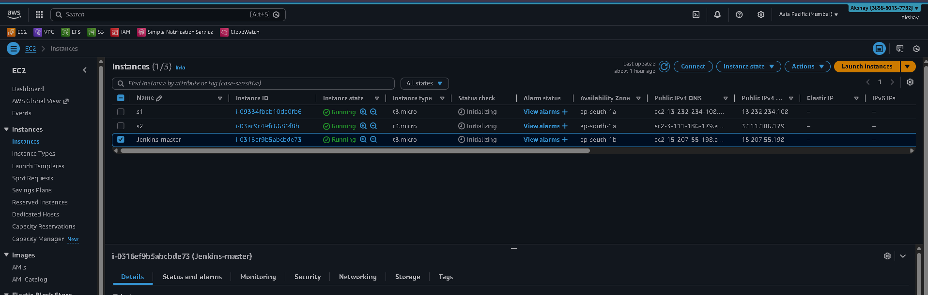

2. Create 2 git branches
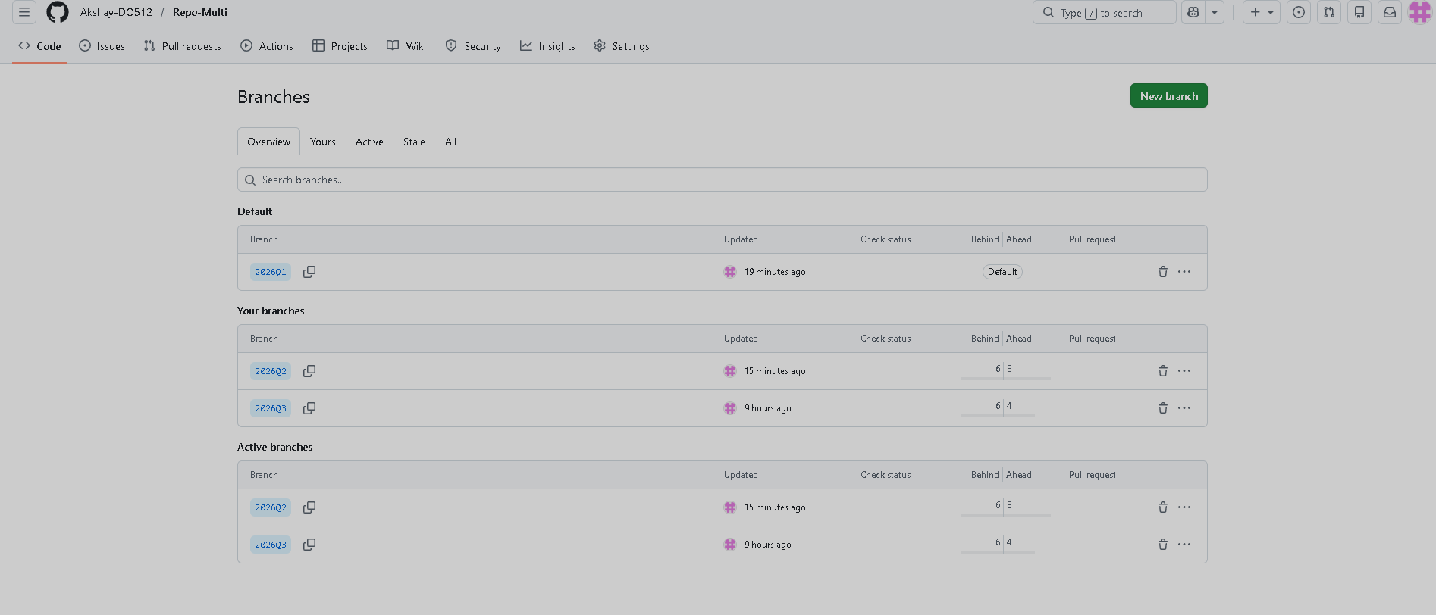

3. configure the connection between Jenkins and github with the help of webhooks.
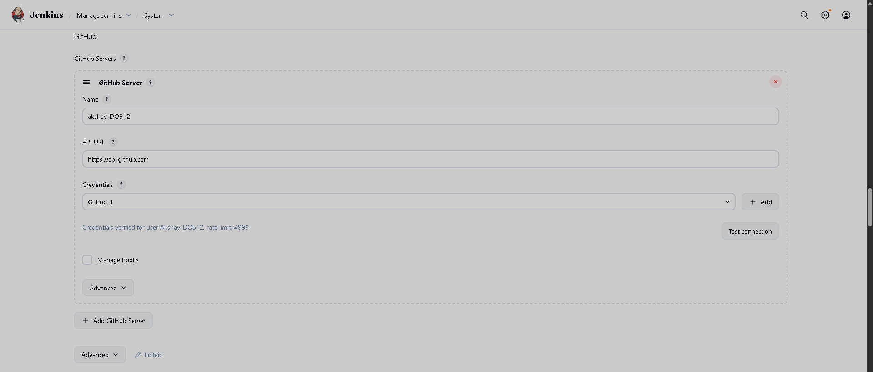
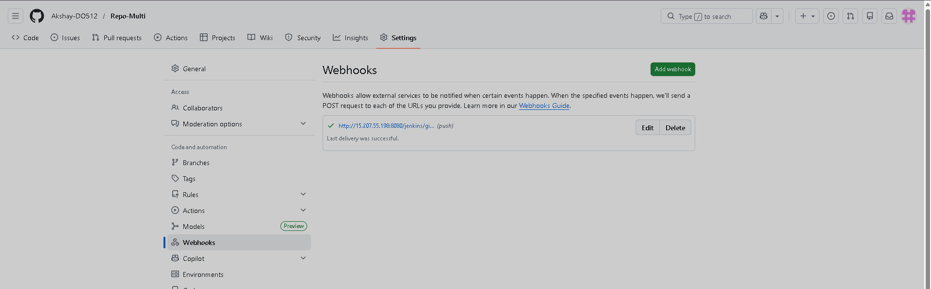

4. Jenkins pipeline job
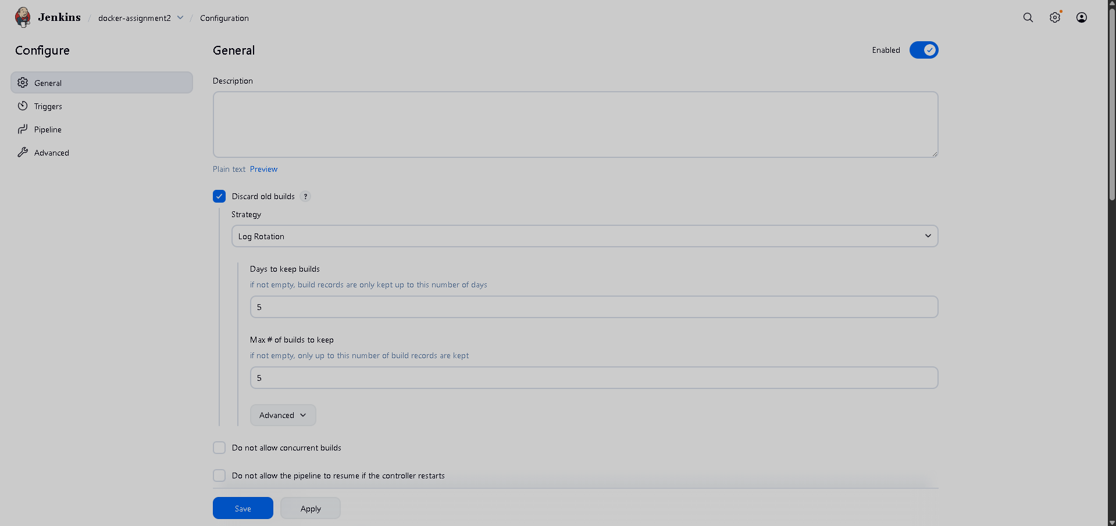
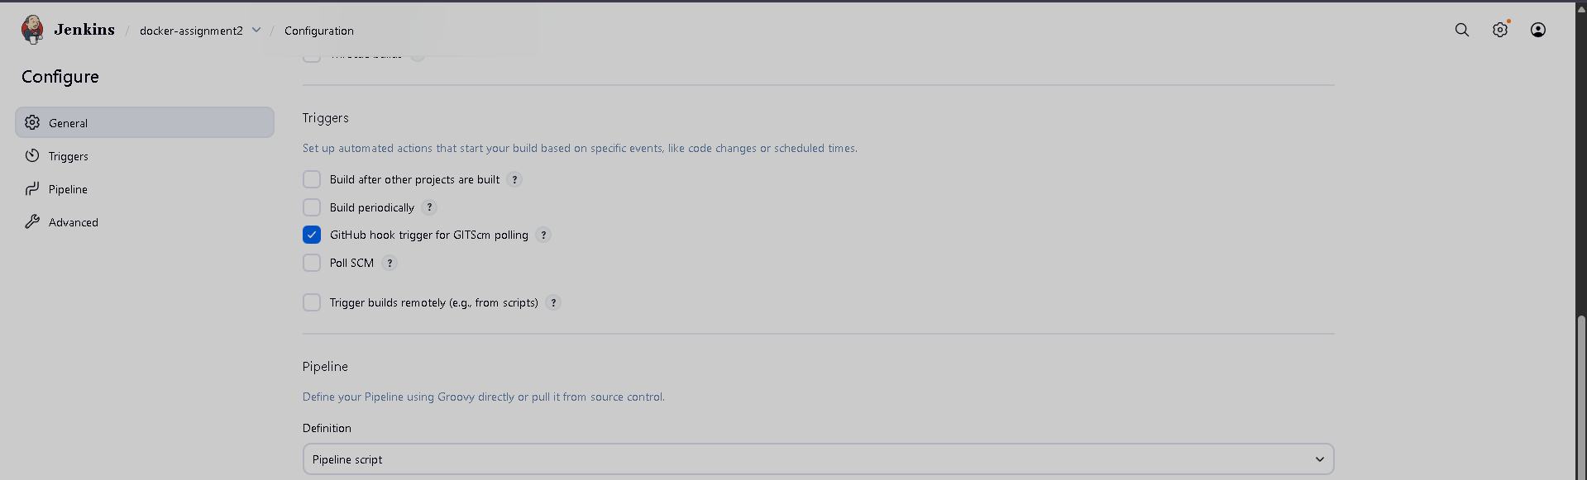
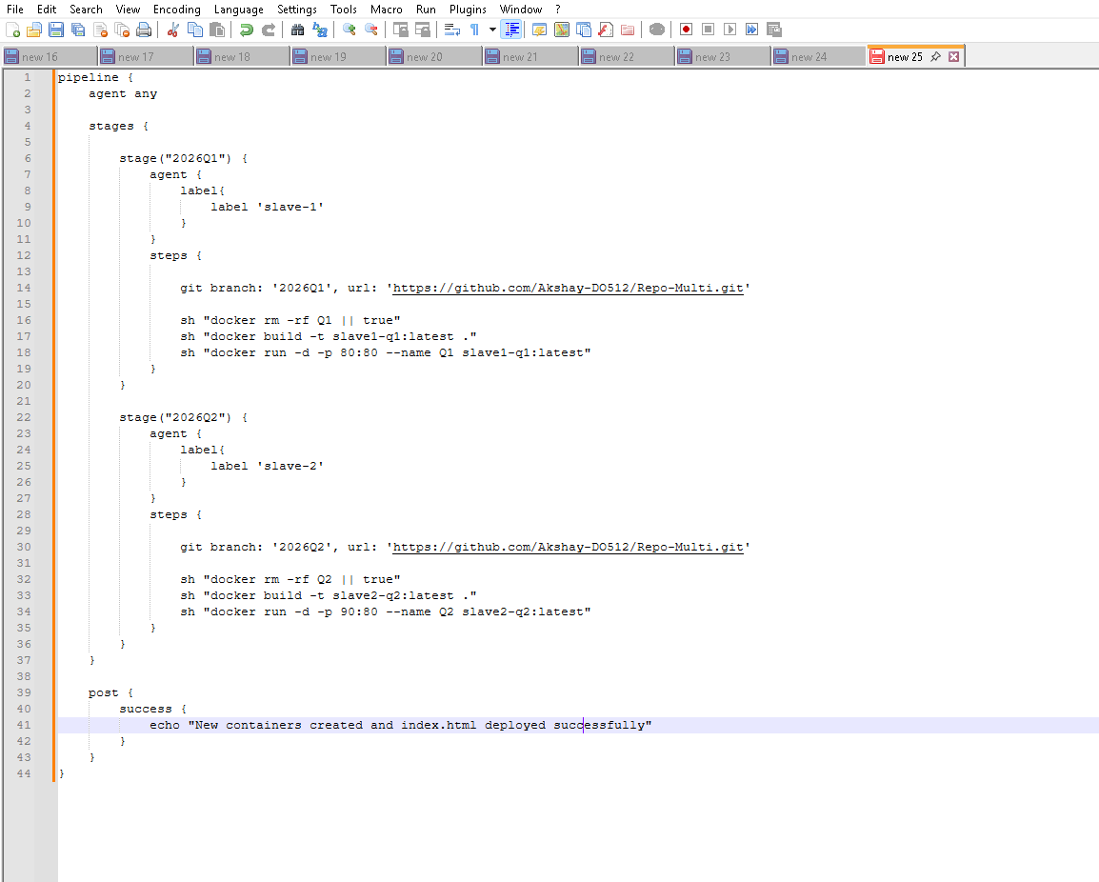

5. Dockerfile
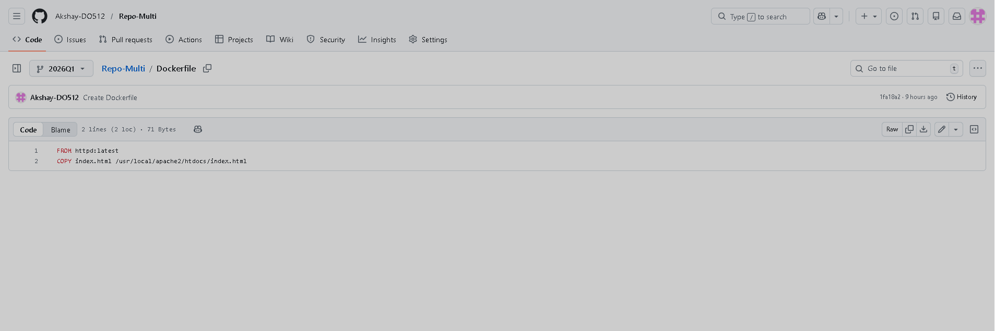

Output:
